[ME EN 2450 Memo

To: ME EN 2450 Students

From: Your name here

Date: April 25th, 2019

Subject: Compressed Air Train Project

Attachments: List your code files here

**Summary**

This section should include at least three sentences that provide the problem statement, the approach used to solve the problem, and the main findings including the solution obtained.

**Numerical Methods**

The first paragraph of this section should provide details of the numerical simulation. The ODEs describing the motion of the train (for both stages) should be included with appropriate initial conditions. Be sure to define all of the symbols and variables in the text. The different numerical methods that were implemented should be clearly stated, along with a description of how the optimal solution is obtained. The step size used in your ODE solver should be noted along with appropriate units. A description of the optimization technique should also be given.

The second paragraph should include a table that lists the relevant physical parameters in the design problem, with the discrete values or ranges allowed for each parameter. A description of how you set reasonable limits on the ranges for each design parameter should also be included. In addition, your table needs to be referenced in the text. For example, you might write, “Table 1 lists all of the relevant design parameters in the problem.” Some of the physical parameters in the problem will be held constant at preset values, such as the drag coefficient *Cd*, rolling resistance coefficient *Cr*, air density *a*, mass of the wheels *mw*, diameter of the wheels *Dw*, atmospheric pressure *P*atm, and coefficient of static friction *s*. You will need to come up with appropriate values/ranges for all of the parameters. The second paragraph in this section should also list the specific design constraints. For example, the train cannot be longer than the section of “set-up” track or wider/taller than the tunnel. Also, wheel slippage must be avoided.

**Table 1.** Relevant physical parameters in the design problem

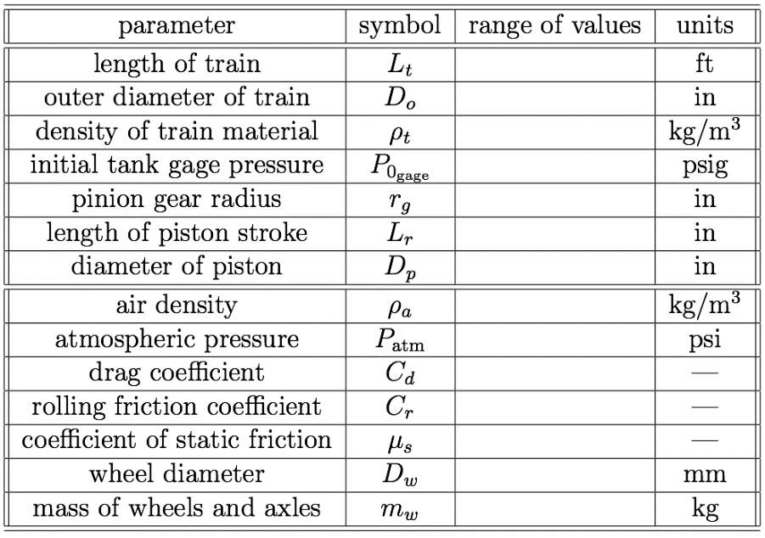

**Numerical Results**

This section should include two figures and one table as shown below. The table below is a summary of the simulation results, including computational time, number of iterations, maximum distance traveled, time to reach the finish line, and a list of the optimum physical parameters. The first figure is a plot of the distance traveled by the train versus time, based on your numerical simulation using the optimum set of physical parameters found. The table should list the optimum values of the physical parameters as found by your selected search algorithm. The figures and table need to be referenced in the main text. For example, your memo should include a sentence similar to the following: “Figure 1 shows a plot of the distance traveled versus time for the optimal train design”. Comment on maximum distance traveled and how fast the train reaches the finish line in the main text. Note, in order to be competitive, your train cannot run off the end of the track. This means distance traveled should be constrained to 10-12.5 m.

**Table 2.** Summary of optimal train results

[Table containing summary of results]

[plot of x (m) and v (m/s) versus t (sec) for your optimal solution – include two horizontal dashed lines that indicate the finish line and the end of the runout track AND one vertical dashed line that indicates *tf*, the time to cross the finish line. The plot should have two scales, one for x on the left vertical axes and one for v on the right. See ExamplePlot.pdf for an example.]

**Figure 1.** Plot of distance traveled versus time for the optimal train design.

**Table 3.** Optimal set of physical parameters

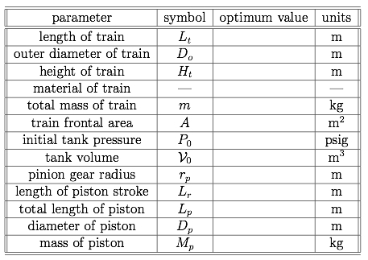

**Realistic Train Design**

Once you have an optimum design solution from your numerical simulation, it is important to then determine how to actually build that design. In this section, you will discuss your selection of realistic components. Selections must be justified based on the availability of materials and components (i.e., what can be purchased off-the-shelf) with consideration to the output from your code. For example, you might say something like “The numerical solution indicated an optimal tank diameter of 1.63 inches. Because PVC pipe only comes in standard sizes of [insert here], however, an actual tank diameter of 1.5 inches is used in the final design”. If the dimensions of your realistic train are different than those output from your numerical solution, then you need to rerun the simulation on your *realistic* train to verify that it successfully finishes the race without running off the end of the track. You should state the time that your realistic train crosses the finish line and the total distance traveled. In this section, you also need to provide a parts list. Similar to the previous section, your table needs to be referenced in the main text.

**Table 4.** Parts list for final train design

[parts list including size, model number, vendor, estimated price for each component]

**Attached Codes**

Be sure to attach original code that is necessary to run your simulation (you do not need to attach the instructor provided code if you do not modify it). The codes should be described somewhere in the body of the memo, as appropriate. Note that, any code not explicitly referenced in the body of the memo will not be considered for grading.